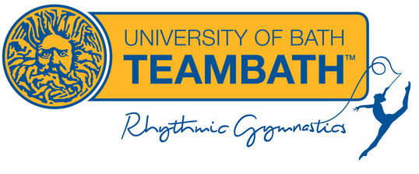

Safe Recruitment Policy

Introduction

At Team Bath Rhythmic Gymnastics we are committed to safeguarding and protecting all our members from abuse. The safety and wellbeing of children at our club is central to everything we do. We recognise that children need a safe, protective, and nurturing environment to fulfil their potential and excel at gymnastics.

Safe recruitment requires safeguarding issues to be considered at every stage of the recruitment process when appointing to a position working or volunteering with children. Although the vast majority of coaches and officials/helpers are committed, dedicated people who are motivated to work within the sport for commendable reasons, it is vital that all reasonable steps are taken to ensure that any unsuitable people or people who may abuse children are prevented from working with young people.

Club Statement

At TBRG we follow robust recruitment procedures to ensure that we recruit individuals who share our values and approach to safeguarding as well as providing an effective deterrent to anyone who wants to abuse children within the sport. These procedures are in place for both paid and voluntary roles at the club and are followed at all times, even if there is only one applicant for a position.

We are fully committed to following the British Gymnastics policy ‘Safeguarding Children: Safe Recruitment’. A full copy of this policy is available here

Welfare Team
March 2024



